Ethyn Nguyen - Student ID: 1001930354

Jorge Catano - Student ID: 1002149092

# Part 2: View-based questions:

Create a view **ItemView** that displays a list of records where each record is comprised of the itemId as **iId**, item name as

**ItemName**, the number of items sold as **NoOfBoxes**, the item price as **ItemPrice**, the revenue generated by each item as

**ItemRevenue**, and the number of customers as **ItemCustomers** who bought the items at any Shop.

Write a SQL query to display the contents of the view **ItemView**:

CREATE VIEW ItemView AS

SELECT

i.iId AS iId,

i.Iname AS ItemName,

COALESCE(SUM(oi.Icount), 0) AS NoOfBoxes,

i.Sprice AS ItemPrice,

COALESCE(SUM(oi.Icount * i.Sprice), 0) AS ItemRevenue,

COUNT(DISTINCT o.cId) AS ItemCustomers

FROM ITEM AS i

LEFT JOIN ORDER_ITEM AS oi ON i.iId = oi.iId

LEFT JOIN `ORDER` AS o ON oi.oId = o.oId

GROUP BY i.iId, i.Iname, i.Sprice;

1. Use the view ItemView to retrieve a list of records where each record is comprised of item Id, item name, the number of boxes of items sold, and the price of each box of the item for all items that cost more than $3.00 and that have been bought by customers.

SELECT

iId,

ItemName,

NoOfBoxes,

CONCAT('$', FORMAT(ItemPrice, 2)) AS ItemPrice

FROM Itemview

WHERE ItemPrice > 3.00 AND NoOfBoxes > 0;

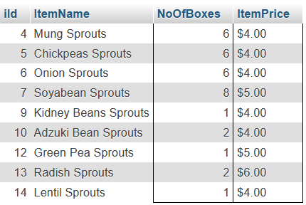

1. Use the view ItemView to retrieve a list of records where each record is comprised of the item Name and the ItemRevenue for the item(s) that generated the minimum revenue in the database.

SELECT

ItemName,

CONCAT('$', FORMAT(ItemRevenue, 2)) AS MinItemRevenue

FROM ItemView

WHERE ItemRevenue = (SELECT MIN(ItemRevenue) FROM ItemView);

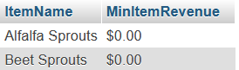

1. Use the view ItemView to generate the min, max and average revenue generated by all the items in the ItemView.

SELECT

CONCAT('$', FORMAT(MIN(ItemRevenue), 2)) AS MinItemRevenue,

CONCAT('$', FORMAT(MAX(ItemRevenue), 2)) AS MaxItemRevenue,

CONCAT('$', FORMAT(AVG(ItemRevenue), 2)) AS AvgItemRevenue

FROM ItemView;

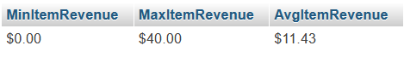

1. Use the view ItemView to retrieve a list of records where each record is comprised of an item name along with the number of customers who bought it. Sort the list by the number of customers in descending order followed by item names in an ascending order.

SELECT

ItemName,

ItemCustomers

FROM ItemView

ORDER BY

ItemCustomers DESC,

ItemName ASC;

1. Use the view ItemView to retrieve the total revenue earned, the total number of boxes sold and the average revenue per box sold by Arlington Herbal Shop as stored in the database.

SELECT

CONCAT('$', FORMAT(SUM(ItemRevenue), 2)) AS TotalRevenue,

SUM(NoOfBoxes) AS TotalNoOfBoxes,

CONCAT('$', FORMAT(AVG(ItemRevenue / NoOfBoxes), 2)) AS 'AvgRevenue/Box'

FROM ItemView;

